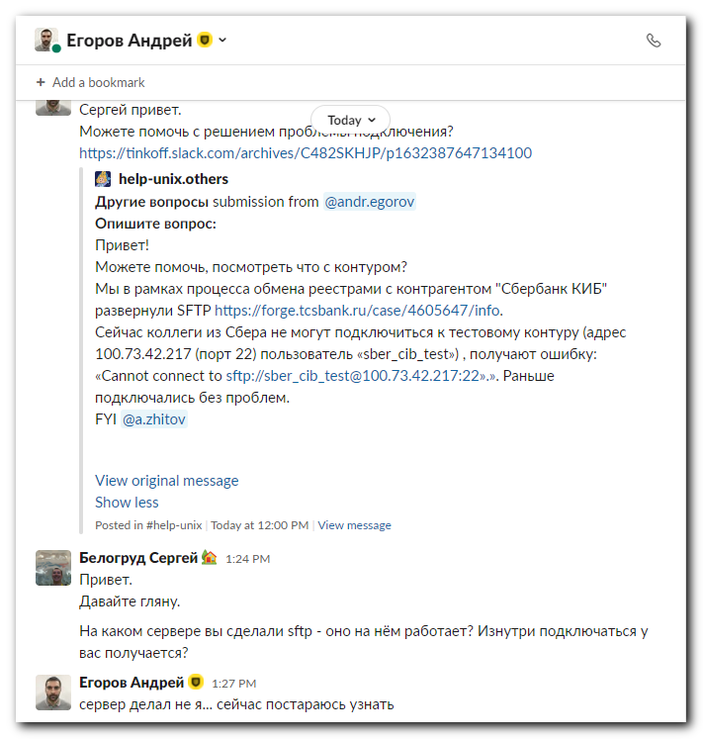
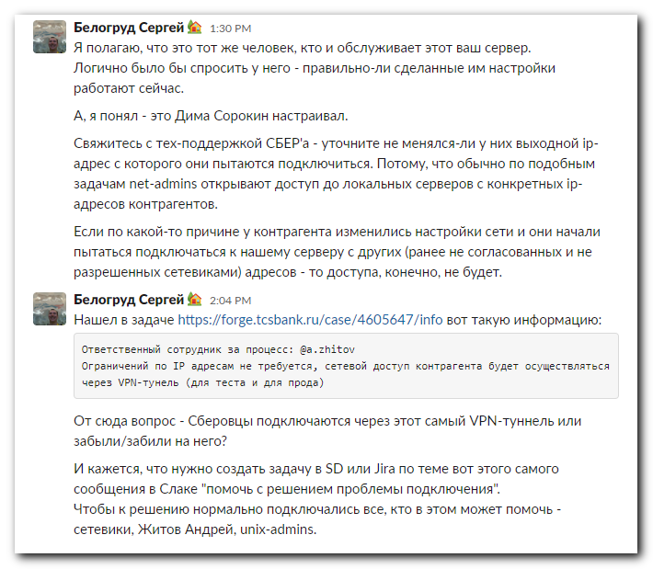

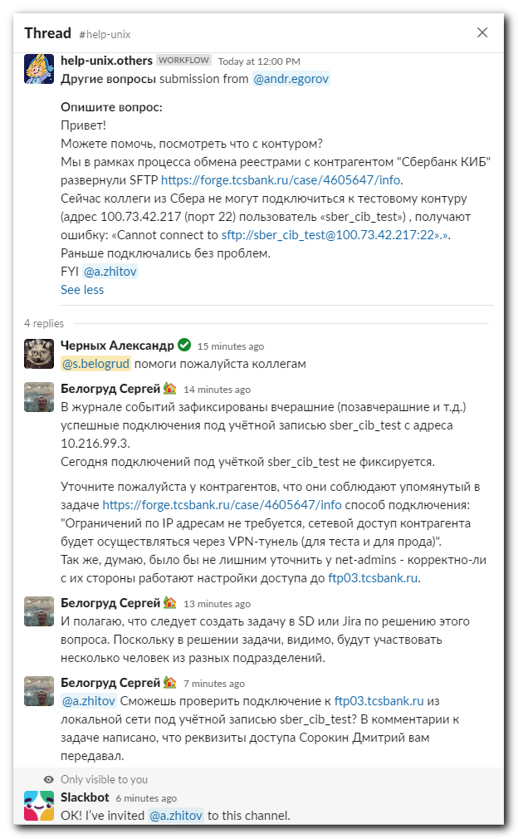
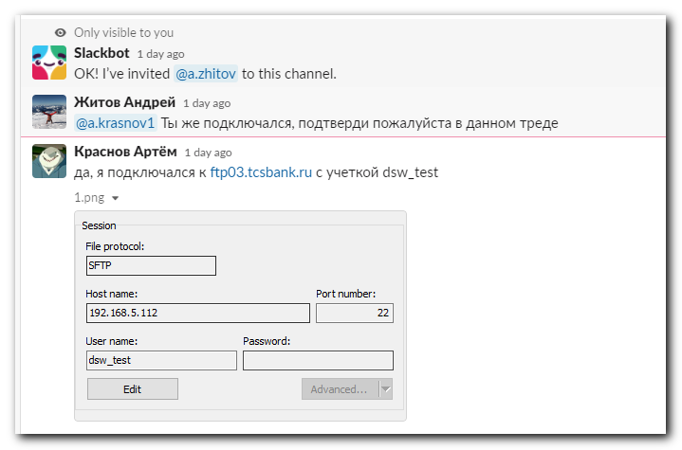

*. В Слаке. Пропал доступ у контрагента по sftp к ftp03.tcsbank.ru. (https://tinkoff.slack.com/archives/C482SKHJP/p1632387647134100)(https://tinkoff.slack.com/archives/D02F6S48Q14/p1632392612000500). Проверил журналы событий и подключаемость из локальной сети к ftp03. Похоже, что что-то у контрагента (не через vpn-туннель подключается, как это было упомянуто в задаче) или у сетевиков. Написал комментарии в Слаке. Попросил создать задачу в SD или Jira.

[root@vm-dmz-app112 ~]# id sber_cib_test
uid=20021(sber_cib_test) gid=496(sftpusers) groups=496(sftpusers)
[root@vm-dmz-app112 ~]# id dsw_test
uid=20022(dsw_test) gid=496(sftpusers) groups=496(sftpusers)
[root@vm-dmz-app112 ~]#

[root@vm-dmz-app112 ~]# ls -Alh /home/sftp/sber_cib_test/
total 8.0K
drwxr-xr-x 2 root root 4.0K May 18 16:37 dev
drwxrwxr-x 4 sber_cib_test sftpusers 4.0K Aug 27 14:12 TINKOFF
[root@vm-dmz-app112 ~]# ls -Alh /home/sftp/dsw_test/
total 20K
-rw-r--r-- 1 dsw_test sftpusers 18 Oct 16 2014 .bash_logout
-rw-r--r-- 1 dsw_test sftpusers 176 Oct 16 2014 .bash_profile
-rw-r--r-- 1 dsw_test sftpusers 124 Oct 16 2014 .bashrc
drwxr-xr-x 4 root root 4.0K May 18 16:35 sber_cib_test
-rw-r--r-- 1 dsw_test sftpusers 658 Jun 23 2012 .zshrc
[root@vm-dmz-app112 ~]#

[root@vm-dmz-app112 ~]# id sber_cib
uid=20019(sber_cib) gid=496(sftpusers) groups=496(sftpusers)
[root@vm-dmz-app112 ~]# id dsw
uid=20020(dsw) gid=496(sftpusers) groups=496(sftpusers)
[root@vm-dmz-app112 ~]# ls -Alh /home/sftp/sber_cib
total 4.0K
drwxrwxr-x 4 sber_cib_test sftpusers 4.0K Feb 16 2021 TINKOFF
[root@vm-dmz-app112 ~]# ls -Alh /home/sftp/dsw/
total 20K
-rw-r--r-- 1 dsw sftpusers 18 Oct 16 2014 .bash_logout
-rw-r--r-- 1 dsw sftpusers 176 Oct 16 2014 .bash_profile
-rw-r--r-- 1 dsw sftpusers 124 Oct 16 2014 .bashrc
drwxr-xr-x 3 root root 4.0K Feb 16 2021 sber_cib
-rw-r--r-- 1 dsw sftpusers 658 Jun 23 2012 .zshrc
[root@vm-dmz-app112 ~]#

[root@vm-dmz-app112 ~]# ls -Alh /var/log/messages* | tail
-rw------- 1 root root 13K Sep 14 03:42 /var/log/messages-20210914.gz
-rw------- 1 root root 12K Sep 15 03:30 /var/log/messages-20210915.gz
-rw------- 1 root root 12K Sep 16 03:45 /var/log/messages-20210916.gz
-rw------- 1 root root 12K Sep 17 03:10 /var/log/messages-20210917.gz
-rw------- 1 root root 13K Sep 18 04:11 /var/log/messages-20210918.gz
-rw------- 1 root root 11K Sep 19 03:35 /var/log/messages-20210919.gz
-rw------- 1 root root 10K Sep 20 04:48 /var/log/messages-20210920.gz
-rw------- 1 root root 11K Sep 21 03:37 /var/log/messages-20210921.gz
-rw------- 1 root root 11K Sep 22 03:32 /var/log/messages-20210922.gz
-rw------- 1 root root 9.8K Sep 23 03:21 /var/log/messages-20210923.gz
[root@vm-dmz-app112 ~]#

[root@vm-dmz-app112 ~]# zegrep -ie "sber_cib" /var/log/secure-2021092*.gz
/var/log/secure-20210921.gz:Sep 20 16:16:51 vm-dmz-app112 sshd[14984]: Accepted password for sber_cib_test from 10.216.99.3 port 42164 ssh2
/var/log/secure-20210921.gz:Sep 20 16:16:51 vm-dmz-app112 sshd[14984]: pam_unix(sshd:session): session opened for user sber_cib_test by (uid=0)
/var/log/secure-20210921.gz:Sep 20 16:16:51 vm-dmz-app112 sshd[14993]: session opened for local user sber_cib_test from [10.216.99.3]
/var/log/secure-20210922.gz:Sep 21 15:26:47 vm-dmz-app112 sshd[6745]: session closed for local user sber_cib_test from [10.216.99.3]
/var/log/secure-20210922.gz:Sep 21 15:26:47 vm-dmz-app112 sshd[6736]: pam_unix(sshd:session): session closed for user sber_cib_test
/var/log/secure-20210922.gz:Sep 21 15:27:44 vm-dmz-app112 sshd[6444]: session closed for local user sber_cib_test from [10.216.99.3]
/var/log/secure-20210922.gz:Sep 21 15:27:44 vm-dmz-app112 sshd[14993]: session closed for local user sber_cib_test from [10.216.99.3]
/var/log/secure-20210922.gz:Sep 21 15:27:44 vm-dmz-app112 sshd[6433]: pam_unix(sshd:session): session closed for user sber_cib_test
/var/log/secure-20210922.gz:Sep 21 15:27:44 vm-dmz-app112 sshd[14984]: pam_unix(sshd:session): session closed for user sber_cib_test
/var/log/secure-20210922.gz:Sep 21 15:30:13 vm-dmz-app112 sshd[8296]: Accepted password for sber_cib_test from 10.216.99.3 port 48236 ssh2
/var/log/secure-20210922.gz:Sep 21 15:30:13 vm-dmz-app112 sshd[8296]: pam_unix(sshd:session): session opened for user sber_cib_test by (uid=0)
/var/log/secure-20210922.gz:Sep 21 15:30:13 vm-dmz-app112 sshd[8301]: session opened for local user sber_cib_test from [10.216.99.3]
/var/log/secure-20210922.gz:Sep 21 15:31:16 vm-dmz-app112 sshd[8589]: Accepted password for sber_cib_test from 10.216.99.3 port 48920 ssh2
/var/log/secure-20210922.gz:Sep 21 15:31:16 vm-dmz-app112 sshd[8589]: pam_unix(sshd:session): session opened for user sber_cib_test by (uid=0)
/var/log/secure-20210922.gz:Sep 21 15:31:16 vm-dmz-app112 sshd[8598]: session opened for local user sber_cib_test from [10.216.99.3]
/var/log/secure-20210923.gz:Sep 22 13:11:44 vm-dmz-app112 sshd[8824]: Accepted password for sber_cib_test from 10.216.99.3 port 56830 ssh2
/var/log/secure-20210923.gz:Sep 22 13:11:44 vm-dmz-app112 sshd[8824]: pam_unix(sshd:session): session opened for user sber_cib_test by (uid=0)
/var/log/secure-20210923.gz:Sep 22 13:11:44 vm-dmz-app112 sshd[8829]: session opened for local user sber_cib_test from [10.216.99.3]
/var/log/secure-20210923.gz:Sep 22 13:20:46 vm-dmz-app112 sshd[11304]: Accepted password for sber_cib_test from 10.216.99.3 port 34134 ssh2
/var/log/secure-20210923.gz:Sep 22 13:20:46 vm-dmz-app112 sshd[11304]: pam_unix(sshd:session): session opened for user sber_cib_test by (uid=0)
/var/log/secure-20210923.gz:Sep 22 13:20:46 vm-dmz-app112 sshd[11313]: session opened for local user sber_cib_test from [10.216.99.3]
/var/log/secure-20210923.gz:Sep 22 16:55:19 vm-dmz-app112 sshd[8598]: session closed for local user sber_cib_test from [10.216.99.3]
/var/log/secure-20210923.gz:Sep 22 16:55:19 vm-dmz-app112 sshd[8589]: pam_unix(sshd:session): session closed for user sber_cib_test
/var/log/secure-20210923.gz:Sep 22 16:56:23 vm-dmz-app112 sshd[11313]: session closed for local user sber_cib_test from [10.216.99.3]
/var/log/secure-20210923.gz:Sep 22 16:56:23 vm-dmz-app112 sshd[8301]: session closed for local user sber_cib_test from [10.216.99.3]
/var/log/secure-20210923.gz:Sep 22 16:56:23 vm-dmz-app112 sshd[8829]: session closed for local user sber_cib_test from [10.216.99.3]
/var/log/secure-20210923.gz:Sep 22 16:56:23 vm-dmz-app112 sshd[8296]: pam_unix(sshd:session): session closed for user sber_cib_test
/var/log/secure-20210923.gz:Sep 22 16:56:23 vm-dmz-app112 sshd[8824]: pam_unix(sshd:session): session closed for user sber_cib_test
/var/log/secure-20210923.gz:Sep 22 16:56:23 vm-dmz-app112 sshd[11304]: pam_unix(sshd:session): session closed for user sber_cib_test
/var/log/secure-20210923.gz:Sep 22 16:59:15 vm-dmz-app112 sshd[6407]: Accepted password for sber_cib_test from 10.216.99.3 port 36922 ssh2
/var/log/secure-20210923.gz:Sep 22 16:59:15 vm-dmz-app112 sshd[6407]: pam_unix(sshd:session): session opened for user sber_cib_test by (uid=0)
/var/log/secure-20210923.gz:Sep 22 16:59:15 vm-dmz-app112 sshd[6412]: session opened for local user sber_cib_test from [10.216.99.3]
/var/log/secure-20210923.gz:Sep 22 17:00:21 vm-dmz-app112 sshd[6726]: Accepted password for sber_cib_test from 10.216.99.3 port 37690 ssh2
/var/log/secure-20210923.gz:Sep 22 17:00:21 vm-dmz-app112 sshd[6726]: pam_unix(sshd:session): session opened for user sber_cib_test by (uid=0)
/var/log/secure-20210923.gz:Sep 22 17:00:21 vm-dmz-app112 sshd[6735]: session opened for local user sber_cib_test from [10.216.99.3]
[root@vm-dmz-app112 ~]#
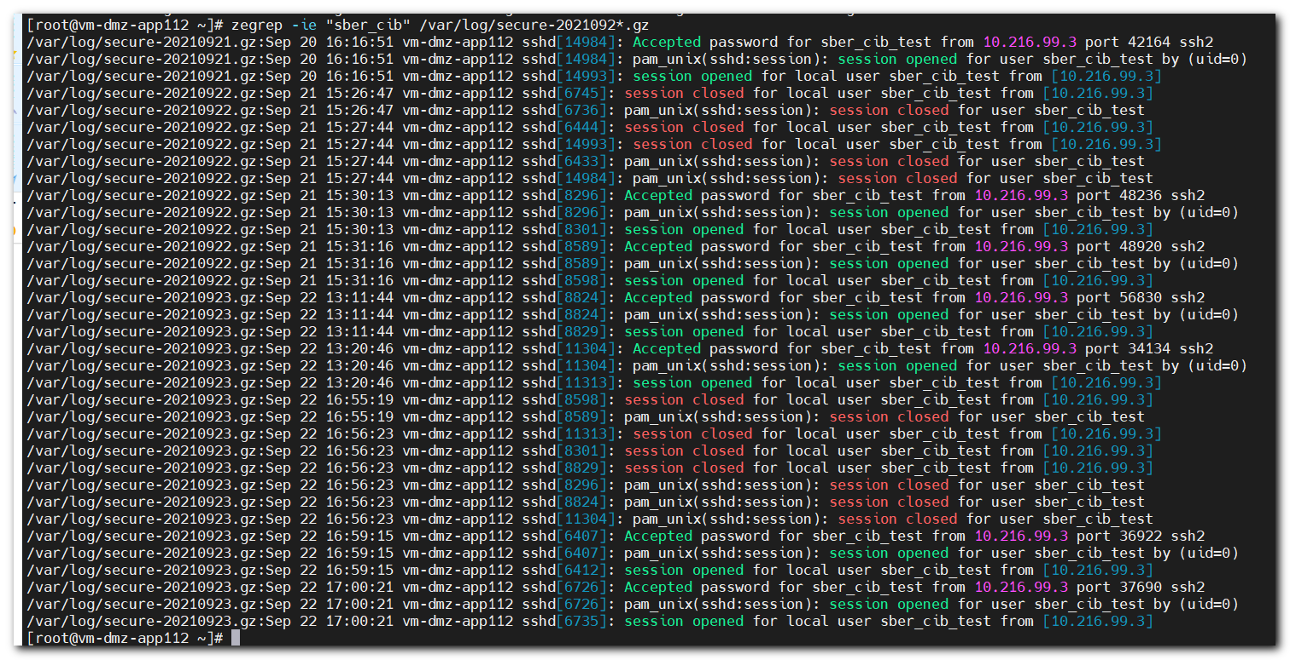

[s.belogrud@nb2339]# sftp sber_cib_test@ftp03.tcsbank.ru
sber_cib_test@ftp03.tcsbank.ru's password:
[s.belogrud@nb2339]#

# Tests from outside of local network.
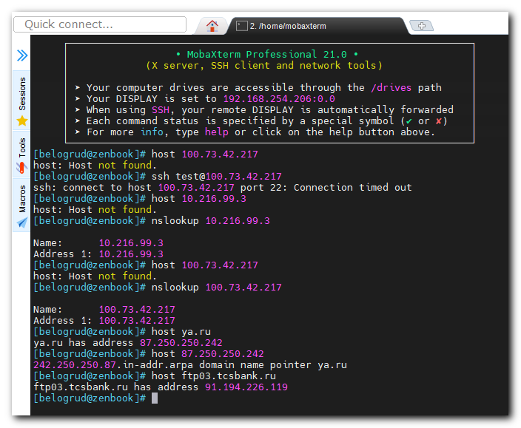
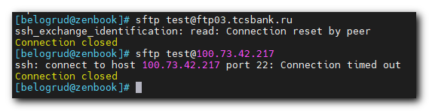

#
# 20210924
# I see lot connections on 23.09 (yesterday).
# I think troubles gone.
